The Clicky Click
IQS has gremlins and sometimes it appears everything is good but a qualification won’t show up in IROC. If this happens, nine times out of ten, doing the “clicky click” will fix the problem. I recommend doing this while on the phone with GPC – they will know quickly if it worked. If this doesn’t fix the problem, I will need to take a look.
- Log into IQS and select the person with the issue.

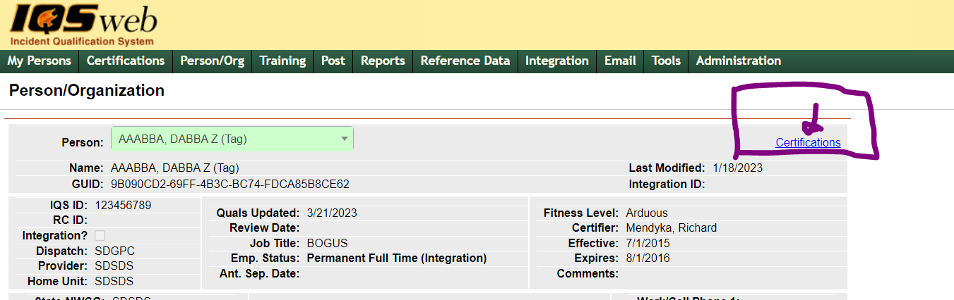
- On the Person/Organization page click on Certifications in the upper right hand corner.

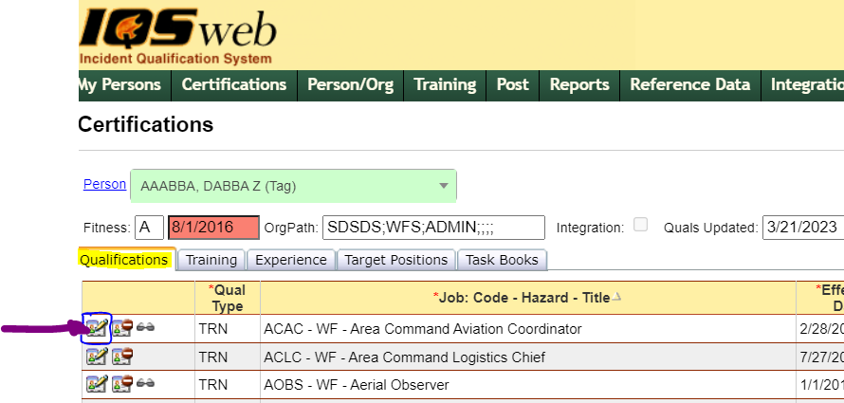
- Making sure you are on the qualifications tab, find the qualification not showing in IROC and click on the edit button (in blue box).

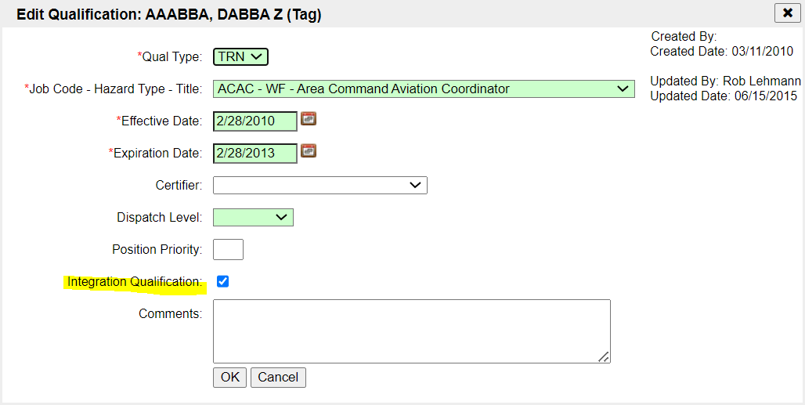
- This will open the following screen:
- Unclick the Integration Qualification button and click ok.

- Repeat step 3 and reclick the Integration Qualification button and press ok.

- This resends the qualification to IROC and GPC should now be able to see it.

